MGCC F, Z and Modern Register
Sundowner Run 2020

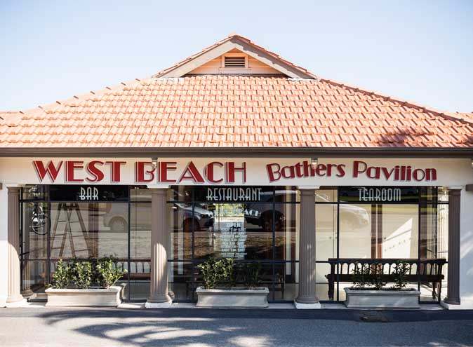

Dinner and watch the sunset at West Beach Pavilion, St Kilda Beach
Meet at McDonalds Restaurant Wallan 4PM for 430PM departure.
We will be seated outside unless weather is bad.
SATURDAY 29th February 7PM
Dinner (Pizza and “comfort food”) and drinks order off the menu
Please advise Jon Cannon before 23rd February
indgeo@optusnet.com.au or SMS 0419 888 128
with names, contact details and any dietary requirements

